

(Retired Faculty and Staff)

# **July 1, 2019–June 30, 2020**

# **Officer and Standing Committee Annual Reports**

The Senior Academy has had a productive although unusual year. Attached you will find the individual reports with details of our activities.

I would like to highlight our Lunch and Learn on “The Outlook for the Economy” by TIAA, the holiday presentation by Vernon Williams on the “History of Indiana Avenue”, our co-sponsorship of a Spirit and Place event, “Gods and Aliens: A Conversation on Faith, Science and E.T.” and a Voices from the Senior Academy event including “Naked to the Bone” a history of Radiology and “Bacon Bits” the life and times of Albion Fellow Bacon.

We sponsored a unique Last Lecture, involving a married academic couple, Professors Robertson and Craig McDaniel of the Herron School of Art and Design. Their topic was “Our Journey So Far: Field Notes”.

The Academy continues to provide panel discussions on “Transition to Retirement” given for faculty and staff of the University anticipating retirement. We provided updated information about the retirement transition to Fidelity and we reached out to the Columbus campus to build a bridge to that group of retirees.

The Senior Academy website now offers information on volunteer opportunities on and off campus. We continue to work on our robust database of members that will potentially offer members the opportunity to indicate their interests and communicate with other members.

Thanks to available funds, the Academy was able to offer four scholarships this year as part of the Arthur Mirsky Scholarship Program. This allowed us to include an additional scholarship to an Indianapolis Public School student.

Our calendar was cut short by the Coronavirus. However, the Board continued to meet by Zoom and we are hoping and planning a return to a full program next year.

I would like to thank all the Board Members and Committee Chairs for their hard work and dedication.

Respectfully,

Christy A. Tidwell

President

**IUPUI Senior Academy Finance Committee**

**Annual Report 2019-2020**

The Senior Academy (SA) Finance Committee (membership the same as the Executive Committee) is chaired by the Treasurer. The current 2019-2020 SA annual expense budget is $21,300. The largest SA budgeted expense is $11,000 for scholarships. In addition, substantial financial and administrative support is generously provided by the IUPUI Executive Vice Chancellor’s office. Unfortunately, a number of programs and events had to be canceled in the spring of 2020 due to the pandemic. As a result, expenses were lower than originally projected.

The Finance Committee will prepare and present the SA 2020-2021 budget for board discussion and approval during the July--September 2020 calendar quarter. This budget will 1) display the full financial picture of the Senior Academy with all income/expense sources identified, and 2) provide guidance for officers and committee chairs in planning and implementing projects and events.

The detailed IUPUI Senior Academy Board Treasurer Procedures Manual was prepared this year. This document will provide guidance for the Treasurer and Finance Committee in the coming years.

Quarterly financial statements are prepared for the board. As of March 31, 2020, Senior Academy fund balances were as follows:

IU FOUNDATION ACCOUNTS

SA Scholarship Returning Students $64,952.23

SA Scholarship IPS Students $57,248.36

SA Scholarship General Fund $48,579.21

SA General Endowment Fund $13,732.53

INDIANA MEMBERS CREDIT UNION

Checking Account $2272.39

Savings Account $2484.75

The Senior Academy remains financially stable and solvent.

*Submitted by: Steve Kirchhoff*

*Treasurer*

**IUPUI Senior Academy Program Committee**

**Annual Report 2019-2020**

The Program Committee announced its plan for programs in 2019-2020 in August and most of them did take place and were well attended and received. With the beginning of the corona crises in mid-March the programs planned for April through June had to be suspended or changed, instead of in-person events, meetings had to take place virtually—a regrettable divergence of well-liked traditions.

The academic year started out on 26 September 2019 with one of the Senior Academy’s **Listen and Learn** events. **Transition to Retirement** took place in the Faculty Crossing, a new space in the Center for Teaching and Learning, on the ground floor of the IUPUI University Library. It featured Hugh Hendrie, “Coping with Retirement: Results from 2 Physician Surveys”; Sherry Queener, “Some Retirees’ Tales”; and Christy Tidwell, “Practical Thinking About Retirement.” All three of them presented stories that offered insights into the variety of ways by which people manage to move on after long years of work.

In October (22 October 2019), the Senior Academy collaborated with TIAA to organize a **Lunch and Learn** event. TIAA provided lunch and three of its advisors offered views and answered questions focused on **The Outlook of the 2109 Economy.** Brian Nick, Chief Strategist TIAA, provided a presentation titled “Expect a Tougher Climb.” The event at IUPUI Park 100, 5980 West 71st Street had been planned for some time but it occurred at a critical time, namely shortly after the announcement that the University had elected Fidelity as the only company to manage its retirement accounts—a decision that affected some of the retirees and left quite a few of them confused about the effect of that decision on their retirement accounts.

November has become the traditional time for the **IUPUI Last Lecture.** This Last Lecture (1 November 2019) was unusual in that it featured to people, Jean Robertson and Craig McDaniel, a wife and husband team in the Herron School of Art + Design, both of whom retired this year. As usual the event took place in the Campus Center Theatre, followed by a reception that provided opportunity for socializing among old and new friends across the campus.

Also in November (6 November 2019), the Senior Academy sponsored an event at the Indiana Hebrew Congregation, part of the Spirit and Place Festival 2020: R/Evolution. Members of the Senior Academy served as moderators in small break-out discussion groups and summarized the groups’ main points to the guide the concluding conversation of **Gods and Aliens:** **A Conversation on Faith, Science, and E.T.** A discussion of Cosmology, Evolution, Aliens, and God(s), led by Gabriel Filipelli, Department of Earth Sciences, and Phillip Goff, Center for the Study Religion and American Culture, IUPUI.

At the **IUPUI Health and Benefit Fair** (14 November 2019) the Senior Academy staffed a table with information about the organization. The location of the information table in the Campus Center 450 was excellent and allowed for good visibility and encouraged conversations about the mission and goal of the Academy.

On 12 December 2019 a considerable number of members and their guests gathered for the **Annual Senior Academy Holiday Luncheon** at the Courses Restaurant Ivy Tech, which is managed and staffed by staff and students of the hospitality programs of Community College, 2820 N. Meridian Street on the 13th floor—with a wonderful 360-degree view of Indianapolis. This opportunity to re-connect with friends and make new ones included a presentation of the play “The Price of Progress: The History of Indiana Avenue and IUPUI” by Vernon Williams. The full-length play had been performed in the Campus Center Theatre for the public. Mr. Vernon narrated the shortened production.

In the spring semester, the Senior Academy typically sponsors two IUPUI events. It supports four students to attend the **annual MLK Jr Celebration Dinner** (20 January 2020). The second event, the **annual Joseph E. Taylor Symposium**, which was scheduled for a date later than usual, had to be canceled because of the closing of the campus in reaction to the corona virus threat. In addition, the Senior Academy supported an event of the University Club, Reading at the Table, which took place on 6 February 2020 in the Faculty Crossing space in the Center for Teaching and Learning and featured a presentation by Nancy Chism about the book she published recently, Picking Cotton on the Way to Church.

A day before the cancelled Taylor Symposium (10 March 2020), there was another event in the Faculty Crossing space in the Center for Teaching and Learning. **Listen and Learn: Voices from the IUPUI Senior Academy** featured Mervin Cohen, “Naked to the Bone”: The History of Radiology and Its Truly Amazing Technology,” and Robert Barrows, “Bacon Bits,” about the role of Albion Fellows Bacon in shaping social reform in Indiana in the early nineteenth century

Heeding the Indiana governor’s order for a lockdown of the state to mitigate the severity threatened by the corona virus, Indiana University doubled the period of spring break and closed the campuses in April—a measure that will largely remain in place until August, when the fall semester begins with online classes only. As a result, plans for a meeting with current and retired faculty and staff of IUPUC, combined with a visit of the mid-century J. Irwin Miller House, had to be canceled. Moreover, the **IUPUI Senior Academy Annual Meeting** had to be changed from the traditional luncheon in June to a virtual gathering (16 June 2020)—a webinar facilitated by the ubiquitous Zoom that has become IU’s meeting platform.

*Submitted by: Marianne Wokeck*

*Vice President and Chair – Program Committee*

**IUPUI Senior Academy Membership Committee**

**Annual Report 2019-2020**

The Membership Committee began the year composed of Karen Black, Patti Hair, Diane Billings, and Chair Georgia Miller; Gabrielle Bovenzi joined the committee during the year. In the spring of 2020, Karen and Gabrielle Bovenzi assumed leadership of the Committee and are moving projects forward, continuing through the next year.

The new Membership DataBase (DB) was made available to the Senior Academy (SA) Board at the end of last year for their early use in exploring and accessing the data. We continue to work on cleaning and expanding the data, assuring compliance with University policies on access, and making access and use of information easier.

The SA Membership Center (using the DB) will allow members to access their own profile data via a user portal so they may update some basic personal information, add or change Interests, opt in or out of listing in the internal membership ‘directory’ and pay dues. Access will be via IU passwords.

Next year’s work will include completion of the Membership Center Policies and Procedures document which will be reviewed by legal counsel before being presented to the Board for its review and action by the end of the calendar year. IU policies continue to be our guidance until then.

2020-2021 Project Plan was developed and includes specific items about:

* identifying Columbus retirees
* developing a policies and procedure manual
* Continue to transition to the new database

​We look forward to working with other SA Committees to use the DB and Membership Center for communication and marketing and other work of the Board.

*Submitted by: Georgia B. Miller*

*Chair – Membership Committee*

**IUPUI Senior Academy** **Nominating Committee**

**Annual Report 2019-2020**

**Members of the Committee: Christy Tidwell, Chair. Marianne Wokeck, Vice President. Steve Kirchhoff, Treasurer. Sherry Queener, Past President and Mark Grove and Harriet Wilkins as Members at Large**

The Committee met and reviewed all the names that had been nominated by Board members. No nominations were received from the solicitation of the general membership.

A total of 19 individuals were suggested. The Committee divided the names and each nominated individual was approached. In some cases we were not able to reach the proposed candidate by e-mail, telephone call or in one case a letter.

We are pleased to propose the following list of candidates who have agreed to serve on the Board if elected:

Bill Schneider Faculty, Liberal Arts

Russell Vertner Faculty, School of Business

Becky Porter Faculty, Enrollment Mgt, Physical Therapy, Former Deans

Fran Huehls *(one year only)* Faculty, Philanthropic Studies

Christine Fitzpatrick Faculty, Chancellor’s Chief of Staff, Engineering and Tech

Other nominations can be made from the floor at the Board Meeting.

We are also pleased to offer a proposed slate of officers for the 20/21 year:

Marianne Wokeck President

Georgia Miller Vice President

Gabrielle Bovenzi Treasurer

Anne Belcher Secretary

Other nominations can be made from the floor at the Board Meeting.

*Submitted by: Christy Tidwell*

*President and Chair – Nominating Committee*

**IUPUI Senior Academy Spirit and Place Committee**

**Annual Report 2019-2020**

Committee Members: Anne Belcher, Christy Tidwell, Steve Kirchhoff, Jan Froehlich, Sherry Queener, Trish Severns.

Activities:

* Anne Belcher chaired the committee for 2019-2020 and coordinated support for the IUPUI Spirit and Place event, “Gods and Aliens: A Conversation on Faith, Science and E.T.” The event was held November 6, 2019 at the Indianapolis Hebrew Congregation. Close to 100 people were in attendance for the session. Senior Academy members Marianne Wokeck, Sherry Queener, Steve Kirchhoff, Jan Froehlich, Kathryn Wilson, and Anne Belcher served as small group facilitators following presentations and dialogue among the four speakers. Each Senior Academy member facilitated small group discussions with participants, and reported key insights to the audience as a summary activity for the program. The contribution was well received by the speakers and Spirit and Place staff. Erin Kelley from Spirit and Place requested that the Senior Academy consider co-sponsorship for future IUPUI proposals submitted to the festival.
* Senior Academy board members discussed involvement with the Spirit and Place Festival for the future at the November board meeting. The 2019 program of events showcased several program offerings by IUPUI departments, and the Board determined that the best contribution of the Senior Academy would be partnership/co-sponsorship with existing IUPUI proposals.
* The Spirit and Place theme for 2020 is “Origins” and Senior Academy board members Anne Belcher and Jan Froehlich attended the orientation session February 19, 2020 at WFYI Headquarters in Indianapolis. Four groups from IUPUI were at the meeting, and contact information was exchanged with the IUPUI representatives to encourage collaboration and co-sponsorship for 2020. Grant proposals for this year’s festival are due at midnight, May 1, 2020. Additional correspondence with Erin Kelley, Spirit and Place Program Director, indicates that she will be working with potential grantees to foster Senior Academy collaboration for the 2020 festival.

*Submitted by: Anne E. Belcher*

*Chair – Spirit and Place Committee*

**IUPUI Senior Academy United Way Campaign**

**Annual Report 2019-2020**

The Campaign mailing to membership was mailed the week of September 3, 2019 and included pledge letter, pledge form, return envelope and UWCI (United Way of Central Indiana) bookmark.

The Kick-off Luncheon was held Thursday, September 5. The Senior Academy President and the Senior Academy United Way Representative attended the luncheon as guests of the Office of Academic Affairs and Executive Vice Chancellor, Chief Academic Officer Kathy Johnson.

The 2019 United Way Campaign final report is dated January 16, 2020:

Amount Pledged by Senior Academy as of January 16, 2020

* 34 pledges, $29,664

Leadership Pledges ($1500 or more)

* 9 of 34 members have pledged a total of $24,800

**Total pledges at end of Campaign** – comparison to previous years (per “weekly tracker” report)

|  |  |  |  |  |  |  |  |
| --- | --- | --- | --- | --- | --- | --- | --- |
| Campaign year | Weekly Tracker Report As of: | No. of donors | Amount Pledged | No. of donors  Leadership Level |  |  | Amount  Pledged Leadership |
| 2019 | 1.16.2020 | 34 | $29,664 | 9 |  |  | $24,800 |
| 2018 | 3.19.2019 | 28 | $26,670 | 7 |  |  | $20,361 |
| 2017 | 1.8.2018 | 44 | $31,016 | 6 |  |  | $18,854 |
| 2016 | 1.11.2017 | 34 | $32,916 | 8 |  |  | $23,489 |

**Final Pledge Amount Reported by UWCI.** *Sometimes there are contributions made to UWCI after the final “Weekly Tracker” report which explains any differences in these amount to the table above.*

|  |  |
| --- | --- |
| 2015 | $21,121.00 |
| 2016 | $32,916.73 |
| 2017 | $33,856.25 |
| 2018 | $26,670.94 |
| 2019 | $30,164.00 |

A “Thank You” Reception was held on “Celebrate IUPUI Day”, Tuesday, January 21, 2020 from 4-5p (remarks at 4:30) at Campus Center.

A reception for donors pledging at leadership level was planned for April 29, 2020 at IRT. The reception was cancelled as a result of the COV-19 pandemic.

Letter sent September 3, 2019 to Sr. Academy Membership

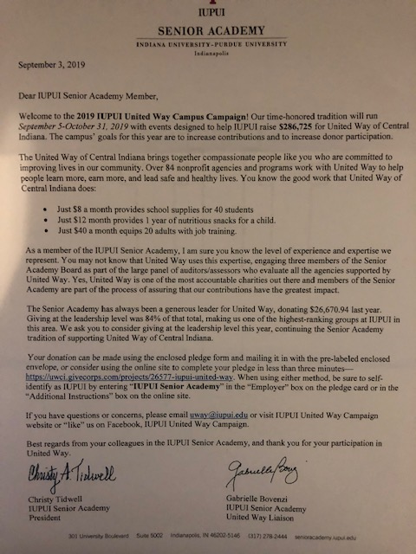

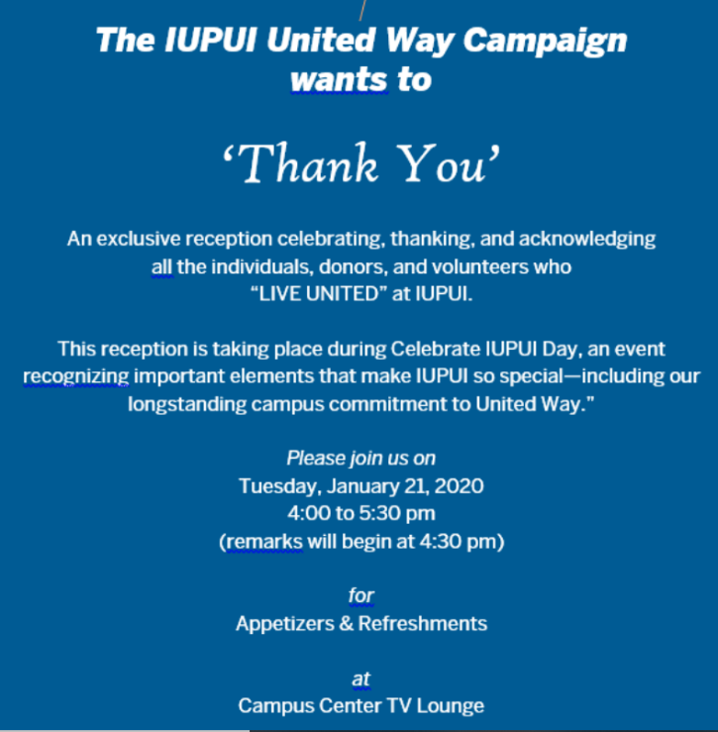

*Submitted by: Gabrielle Bovenzi*

*Updated with additional Table of “Final Pledge Amount Reported by UWCI” 9.1.2020*

*Senior Academy United Way Representative*

**IUPUI Senior Academy Scholarship Committee**

**Annual Report 2019-2020**

The Senior Academy offers three competitive student scholarships through the Arthur Mirsky Scholarship Program.

**Senior Academy Freshman (IPS) Scholarship:** The IPS Scholarship is designed to partially support beginning freshmen from the Indianapolis school system who show the potential for academic excellence at IUPUI. The scholarship is awarded in the second semester of the awardee’s high-school senior-year for enrollment at IUPUI.

**Senior Academy General Scholarship:** The General Scholarship is designed to partially support seniors who demonstrate high achievement and will graduate with a baccalaureate degree at the end of their last spring semester. Applicants must be in good academic standing at IUPUI, having completed 90 credits with a cumulative grade point average of at least 3.50 on a 4.00 scale.

**Senior Academy Returning-Student Scholarship:** The Returning Student Scholarship was designed to help returning students finish their education. This scholarship helps fund tuition and books for students who, in the past, were out of college for at least three years after beginning a degree, but did not finish, and are now planning to re-enroll, or who are currently re-enrolled, to complete their first undergraduate degree. The applicant must (1) meet regular admission/re-admission requirements to IUPUI, (2) have had a grade point average of at least 2.00 on a 4.00 scale for previous college credits, and (3) agree to enroll for at least 6 credit hours per semester.

**The General Scholarship Winner for the Senior Academy Board 2020**

**Evee Lagmay**



Evee Lagmay is a Bachelor of Nursing major. She is a first generation, Asian Hawaiian single mother who has worked full time throughout her undergraduate career. Her commitment to community service is truly exceptional. She has maintained an extremely high GPA. Because of her family obligations, which she has taken on with love and devotion for many years since age 16, she is currently an “older student”. Her scholarship essays indicate a person clearly focused on succeeding in her nursing career and supporting herself without parent assistance. To quote from her essay she is committed “... to hustle through the whirlwind of being a mom, working as a nurse and studying through school.” She is a model leader and exactly the person we look for to choose as a model scholar:

”Throughout nursing school, I gratefully enjoyed influential relationships and began to coordinate helpful study group sessions with my peers. Not only was I able to achieve exceptional grades, I grasped positive attributes of being a leader not only in my studies but most importantly, my life. I learned the importance of accountability, perseverance and community. As I prepare to strive through my nursing career, I’ll continue to use these characteristics towards my everyday decision-making and interactions with others. I’ll continue to advocate for those who need assistance. Ultimately, I’ll continue to share the knowledge I’ve learned from my family and education towards the management and promotion of our own bodies.”

The Senior Academy Scholarship Committee agreed unanimously in its choice of this exceptional person for the winner of the 2020 General Senior Academy Scholarship!

**The Freshman IPS Senior Academy Scholarship Winners for 2020**

The Scholarship Committee had enough funds to select two scholars in one of the scholarship categories. The members voted to choose two IPS scholars.

**Abigail Goerges**



Abigail Goerges is a Hispanic Latino student who attended the Herron Art High School. She has demonstrated an impressive background for political activism from a young age, participating in political marches and contacting elected officials on her own. One reference described her as a world-changer, as well as one of the most hard-working, self-motivated and humble students in his experience.

**Sheyla Tran**

Sheyla Tran attended Crispus Attucks High School and plans on enrolling as a BS Biology major with a medical career choice. One reference notes she has received superb musical training and has achieved superb ability on the violin encouraged by her family. Sheyla documents that her intense focus and commitment to learning music has taught her discipline applicable to other career endeavors. She explains that music is a clear, reasoned, and careful choice that, for her, has been an ongoing challenge that she feels will lead to her sure academic success.

**The Returning Student Scholar Senior Academy Scholarship Winner for 2020**

**Adrienne Shea**



Adrienne Shea started her university studies at IUPU Columbus in 2002. Due to what she describes as a lack of focus, to poor grades, and financial problems, she left school. She returned to her studies after a hiatus of about 15 years. She is transitioning back to IUPUI as a mechanical engineering major. She has spent her time away from school working and raising 2 children and is now 36 years old. In 2018 she re-enrolled as a mechanical engineering major at IUPUC and will now transition to IUPUI. While recently at Columbus she has been highly engaged academically outside her own classes. She has worked in a chemistry lab, as an engineering lab assistant, as a math tutor in calculus and as a tutor in various other subjects such as chemistry and physics. Her references both have given her their highest scores. She has noted that she has come to love her education in a way “I don't think I could have without my absence."

Members of the review committee reviewed 30 applications for the Senior Academy Freshman IPS Scholarship and 22 applications for the SA General Scholarship and 6 applications for the Returning Scholarship.

The Committee offers its sincere thanks and appreciation to **Erin Steinfort,** theSr Assistant Director of Scholarships, in Student Financial Services. Erin provided support for the Committee’s efforts by carefully screening our applicants to make sure they fulfilled our scholarship requirements. She assisted us in working with the IUPUI on-line scholarship review system.

**Committee Membership**

This year the number of committee members were increased to conform to IRS requirements to include at least one more member from outside the Senior Academy membership than the number of Senior Academy members. The committee currently includes five SA members. Six additional outside members were added to the committee. Members included the following: Mervyn Cohen, Janice Froehlich, Stephen Kirchhoff, David Roberts, and Kathryn Wilson, Chair from the Senior Academy and Etta Ward, Kim Nguyen, Nathen Lohr, Amanda Lumpkin, Kristina Delbridge, and Erin Steinfort from outside the Senior Academy.

*Submitted by: Kathryn J. Wilson*

*Chair – Scholarship Committee*

**IUPUI Senior Academy Communication Committee**

**Annual Report 2019-2020**

**Purpose of Committee**: The purpose is to produce and publish an Academy **Newsletter**, assist in administering and maintaining the Senior Academy **Website**, and initiate other activities and written materials to **promote awareness** to the membership about the Academy and its contributions to the university and the greater community.

**Committee Members**:

Giles Hoyt - Board Member, Chair

Trish Severns – Board Member

Kathryn Wilson – Board Member

Christy Tidwell – Board Member, President

**Activities:**

We thank Mansi Singh for working to keep up our website in cooperation with our IT contact, Chad Beckner. We have up-to-date info there: <http://senioracademy.iupui.edu/>.

Also several of us contribute to our Facebook page, but mostly Trish Severns. Although not all of our members use Facebook, I would encourage people to utilize the Facebook page. It is also an access point for people interested in the Senior Academy.

We have sent out info on events as needed using our e-mail list. Again, we thank Mansi for her help getting the word out about our events.

Distribution of Board items is facilitated using Box currently.

Our brochure is available for distribution.

Thanks also to President Christy Tidwell and other members of the board who have visited university forums to talk about the Senior Academy.

*Submitted by: Giles R. Hoyt*

*Chair – Communications Committee*

**IUPUI Senior Academy Transition to Retirement Committee**

**Annual Report 2019-2020**

The Retirement Concierge ad hoc committee was created in 2019-20 to address topics raised primarily by the Executive Vice Chancellor’s office relating to issues concerning the transition of faculty and staff at IUPUI from employee to retiree. Under the leadership of Janice Froehlich and Marianne Wokeck, this group began to explore programs and support offered at other comparable institutions and needed by new retirees and the potential of a phone bank. The committee only addressed non-financial areas and did not duplicate resources available through other University organizational structures.

Near academic-year-end the name evolved into the Transition to Retirement Committee, charged with developing a strategy and implementation plan for prospective and recent retirees to learn about and have access to information about retirement topics other than those covered by HR such as Medicare and Social Security. The Transition to Retirement Committee will continue to coordinate with IU HR professionals, but its focus is primarily on broader topics concerning retirement such as how to find meaning and purpose in a life no longer shaped by the demands and satisfaction of work at IUPUI/IUPUC.

This project has three major components: (1) identifying and vetting content and resources, (2) developing access mechanisms to include information about online and onsite events of interest, and (3) developing protocols for the implementation of those resources, including clear definition of what information the Senior Academy can provide legally and respectful of members’ privacy.

For 2020-2021 work, a small committee will be established to draft the pieces of the framework of the plan, addressing all phases of the strategy, content and resources, policies and procedures, and the implementation plan.

*Submitted by: Georgia B. Miller*

*Chair – Transition to Retirement Ad-hoc Committee*